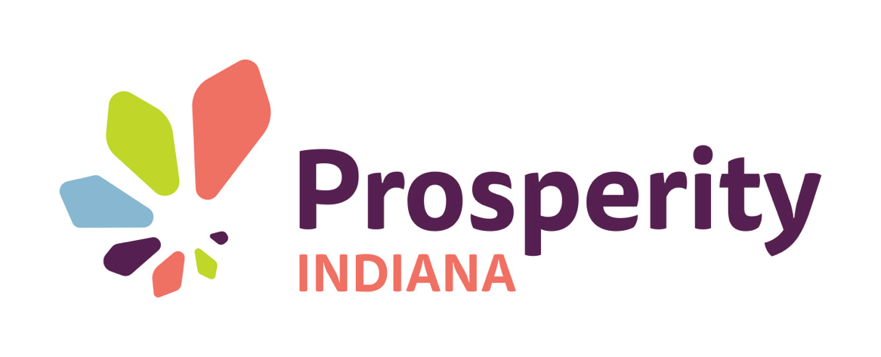

FOR IMMEDIATE RELEASE
June 15, 2017
Contact: Allyson Mitchell, amitchell@prosperityindiana.org, (317) 454-8544

Prosperity Indiana Launches Funding Program for Solar Projects at Nonprofit Organizations Serving Low Income Individuals

Indianapolis, IN - Today, Prosperity Indiana announces the first component of its Solar Uniting Neighbors (SUN) program, which is an effort to fund a total of $350,000 worth of solar projects for community organizations serving low income individuals in Duke Energy Indiana’s electric service territory.

The funding portion of this program is provided by a settlement agreement reached between Duke Energy Indiana, Citizens Action Coalition, Save the Valley, Sierra Club, Valley Watch, the Indiana Office of Utility Consumer Counselor, the Duke Industrial Group, and Nucor Steel. Indiana Association for Community Economic Development (IACED), dba Prosperity Indiana, was named in the settlement agreement as the administrator of the funds. Funding is available, via the settlement, for the purchase and installation of solar installations of less than 0.5MW for community, educational, religious, and nonprofit organizations that serve low income individuals in the Duke Energy Indiana service territory. Organizations interested in applying for funding can download the Request For Project Applications (RFPA) on Prosperity Indiana’s website. Responses are due July 14, 2017 to sun@prosperityindiana.org.

Prosperity Indiana and its partners plan to provide access to solar energy technology in Indiana communities at highly competitive prices in a simple, easy process, while providing information and limited funding to qualifying community organizations who serve low income individuals within the Duke Energy Indiana electric service territory. To make the settlement money go further and do more, Prosperity Indiana and its partners plan to negotiate discounted pricing for pre-evaluated solar products and installers through a transparent, competitive purchasing process (using a Request for Contractor Bids) so the community organizations will not have to burden themselves with becoming experts in solar, or lose time getting and evaluating multiple bids. Similar arrangements have resulted in installed costs that are 10 to 20 percent lower than the going market costs, with a much easier and faster process for new solar owners.

The SUN Program Administration team also plans to provide resources for technical assistance for the development and deployment of Community Solarize programs, the SUN For All Program aimed at increasing the availability of solar for low income households, and the release of a competitive bidding process to select the solar contractors that will evaluate and install the nonprofit solar projects, all of which will be coming soon. The SUN Program Administration Team includes the expertise of the Solar Indiana Renewable Energy Network (SIREN) and Indiana Solar For All. Andy Fraizer, Executive Director of Prosperity Indiana, states “The Solar Uniting Neighbors Program has evolved from its creation in 2014 to better serve our members and the low-income residents they serve.”
Prosperity Indiana is the state's leading community economic development organization. Prosperity Indiana supports a network of organizations that builds vital communities and resilient families. The organization advocates for public policies and assists the network in developing comprehensive solutions that engage local leadership to generate private and public investment for Indiana communities.

